Media Contact:
Haley Sheram / Alison Wentley
BRAVE Public Relations
404.233.3993
hsheram@emailbrave.com
awentley@emailbrave.com

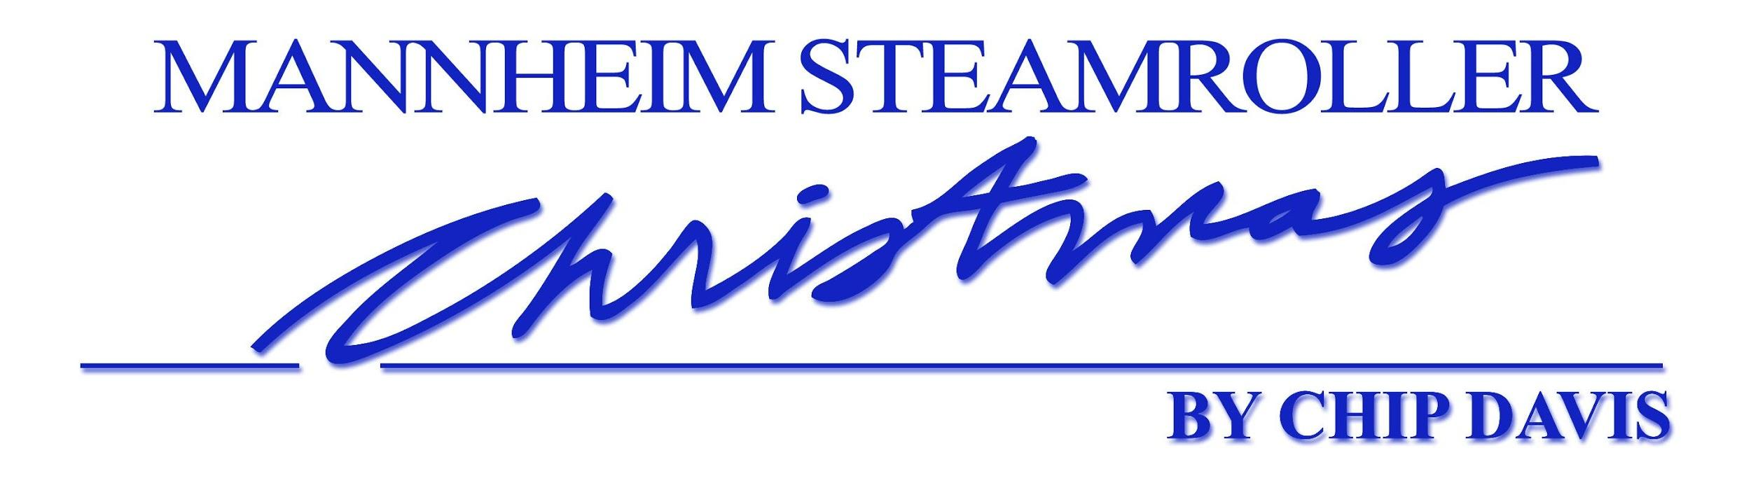

Best Selling Christmas Artist of all Time
Record-Setting Tour is coming to
The Fox Theatre

Do you remember the first time you heard “Mannheim Steamroller Christmas?” Join the celebration as Mannheim Steamroller makes history again – celebrating 35 years of holiday magic as they bring their annual holiday tour to fans throughout the country.
Experience the performance of the No. 1 Christmas music artist in history and for the first time ever, hear the entire album that started it all, LIVE - "Mannheim Steamroller Christmas!"
Sunday, November 24 at the Fox Theatre

ATLANTA (AUGUST 6, 2019) – This fall, Chip Davis, founder and creator of Mannheim Steamroller, will celebrate the 35th Anniversary of his annual Christmas concert tour, making it the longest running consecutive concert tour in the entertainment industry!
Davis’ hallmark tour will begin on November 11, 2019 and run through December 29, 2019. Two traveling ensembles will hold performances in cities across the country.
Mannheim Steamroller will be at the Fox Theatre for two performances on Sunday, November 24. Tickets are on sale now at FoxTheatre.org, the Fox Theatre Ticket Office, and 855-285-8499. Ticket prices start at $45, plus applicable fees. Single-event access to the Marquee Club presented by Lexus will be available for purchase on top of the show ticket. Marquee Club passes are $65 per person and include an enhanced pre-show through post-show experience with complimentary food and non-alcoholic beverages.

“I remember when I came out with my first Christmas album in 1984 followed by our first tour. Back then, many in the music industry said focusing on Christmas just wouldn’t work,” said Davis.
“Now, 35 years later, we are still going strong. I want to thank our fans for making us part of their holiday tradition. Today we often see multi-generational families join us during the holidays each year.”
Davis founded his own record label, American Gramaphone, which went on to become one of the industry’s largest independent record labels. A Grammy Award winner, Mannheim Steamroller has sold more than 40 million albums, 29 million in the Christmas genre. Their holiday CD’s have become synonymous with Christmas and occupy top positions on Billboard’s Seasonal Chart every year.
This year’s show will feature all of the favorite original classic Christmas hits from the first Mannheim Steamroller Christmas album, along with multimedia effects in an intimate setting. Davis will direct and co-produce Tour performances with MagicSpace Entertainment.
Mannheim Steamroller Christmas by Chip Davis is co-produced by MagicSpace Entertainment. The company is headed by Lee D. Marshall, Joe Marsh, John Ballard and Steve Boulay and has been producing and presenting national tours, Broadway shows, concerts and museum exhibits worldwide for over 35 years. They have an office in Park City, UT. www.magicspace.net
###

About the Fox Theatre
The Fox Theatre is one of Atlanta’s premier venues for live entertainment. Listed as No. 1 non-residency venue worldwide for the decade by Billboard Magazine, the Fox Theatre was most recently named as one of the 2018 “Top Stops Worldwide” by Venues Now magazine and landed in the top three of Pollstar magazine’s 2018 Worldwide Ticket Sales. Other notable accolades include nods for 2017 “Theatre of the Year” by the International Entertainment Buyers Association, Rolling Stone magazine’s “The Best Big Rooms in America” as part of their “Venues That Rock” series (2013) and the 2011 “Outstanding Historic Theatre of the Year” award by the League of Historic American Theatres. For the past decade, the Fox Theatre has consistently ranked in the top three non-residency theatres in North America for gross ticket sales by industry trade magazines, Pollstar, Billboard and Venues Now. The Fox Theatre has the No. 1 social media presence for any theatre or performing arts center in North America (2,000-5,000 seats) and for any Georgia venue according to the “Social Media Power 100” compiled by Venues Now magazine. With 4,665 seats in the theatre, the Fox hosts 250 performances a year, from rock concerts and Broadway productions to ballets, comedy and movies, attracting 500,000 visitors annually. In addition, the Fox hosts wedding receptions, trade shows, corporate meetings and association functions in its fabulous ballrooms, lounge and outdoor terrace.

As a 501(c)(3) nonprofit arts organization, the Fox Theatre stands today as a fiercely protected landmark and a nationally acclaimed theater and is celebrating its 90th year in 2019. The Fox Theatre proudly acknowledges its partners for their generous support: Coca-Cola, Lexus, Georgian Terrace Hotel, Georgia Natural Gas, Atlanta Beverage-Yuengling, Regions, and Grady Health System. Tickets for all events are available at the Fox Theatre Ticket Office, online at FoxTheatre.org or toll free at 855-285-8499. For group sales information contact the Fox Theatre at 404- 881-2000, or visit the Fox Theatre website at foxtheatre.org. Please stay connected with the Fox Theatre on Instagram, Twitter, Facebook and by using the hashtag #AtTheFox.

About the Marquee Club Presented by Lexus
The Marquee Club Presented by Lexus is the Fox Theatre’s premium membership club. Adjacent to the theatre, the Moroccan and Middle Eastern-style club is 10,000 square feet of interior and exterior space; five stationary bars; three rooftop environments, including the climate-controlled Conservatory, patio covered Arcade Terrace and the outdoor Rooftop Terrace. Open only during public events at the Fox Theatre, the Marquee Club offers pre-show through post-show access for club guests. Additional amenities include priority pre-sale ticketing notifications, access to private restrooms, concierge guest services and self-parking access to an adjacent lot for some memberships. Single-event access passes for non-members are limited and available on a first come-first serve basis. For more information or to purchase a membership, please call Fox Theatre’s Corporate Partnership, Premium Seating Office at 404-881-2127 or visit FoxTheatre.org/MarqueeClub. Share your Marquee Club Presented by Lexus experience on Instagram at @FoxMarqueeClub and by using the hashtag #FoxMarqueeClub.

About Chip Davis and Mannheim Steamroller
From his longtime home in Omaha, Neb., Mannheim Steamroller creator and founder Chip Davis makes innovative music inspired by the sounds of another age. This former teacher and jingle writer founded the music industry’s largest independent recording label, American Gramaphone, in 1974 when industry executives said Davis’ innovative 18th century instrumental rock sound would never sell. In addition to a Grammy Award, Davis is largely credited with establishing the New Age music category.
His first Christmas album in 1984, revolutionized the making and marketing of holiday music, the album’s success made Christmas records a “must do” for all music artists. With more than 29 million Christmas albums sold, Davis is the #1-selling Christmas artist of all time with Elvis coming in at a distant 17 million holiday records sold. Having 19 gold, 8 multi-platinum and 4 platinum-certified records, Davis is among an elite group of music artists with this number of RIAA records. He is also one of the most successful entrepreneurs in the music industry, offering a rich array of lifestyle products on www.mannheimsteamroller.com including hot chocolate, food, apparel and novelty items. His latest achievement is creating a cutting-edge psychoacoustic technology that is being used in major medical institutions such as Mayo Clinic.

